

**IT3060 Human Computer Interaction**

**3rd Year, 2nd Semester**

Assignment 1

**UX/UI for selcohr.com Website**

Submitted to

Sri Lanka Institute of Information Technology

|  |  |  |
| --- | --- | --- |
| **NAME** | **STUDENT ID** | **EMAIL** |
| Fernando P.T.N | IT20049140 | IT20049140@my.sliit.lk |
| P.A.D.S.D.Dilshan | IT20178154 | IT20178154@my.sliit.lk |
| B.M.G.Peiris | IT20147396 | IT20147396@my.sliit.lk |
| Gunasinghe U.J.H | IT20084318 | IT20084318@my.sliit.lk |
| De Silva K.G.S | IT20037192 | IT20037192@my.sliit.lk |

In partial fulfillment of the requirements for the

Bachelor of Science Special Honors Degree in Information Technology

**21st August 2022**

**Group No:** **2022-WE-S2-12**

**Table of Contents**

Project Description........................................................................................................................... 01

Workload Distribution...................................................................................................................... 02

Alternatives considered..................................................................................................................... 03

User groups identified....................................................................................................................... 03

Usability issues identified by the Students.........................................................................................04

Personas for selected.........................................................................................................................15

Scripts for contextual inquiry for 3 users........................................................................................... 18

Usability issues identified based on contextual inquiry......................................................................21

Ratings of the Usability problems as high medium and low.............................................................. 22

Gantt chart......................................................................................................................................... 23

3 Video links........................................................................................................................................24

References..........................................................................................................................................24

Appendix ............................................................................................................................................25

**Project Description**

In here our focus is to create a better user interface compared to the existing one. There are good websites but with the UI which they have used the user experience is negative on them. This is not good for both parties who are users and server providers. In HCI, it shows the interaction within computer and its user. The UI’s involved in this interaction should be user friendly.

For our project we have chosen “selcohr” which is a website which can be used to source and effect, with due diligence and care, highly suitable and rewarding overseas employment for aspiring Sri Lankans thus enhancing the quality of their lives. The UIs of the website are completely out the modern structure and there are lot of errors all over the website. We were able to identify all the necessary details from the expert parties and our perspective is to create a much more user-friendly efficient website where the users can surf through without any problem.

|page 01|

**Workload Distribution**

|  |  |  |
| --- | --- | --- |
| **NO** | **STUDENT NAME** | **SELECTED PAGES** |
| Member 1 | Gunasinghe U.J.H | * Employer_register1.php UI design (crud) * History page UI design * Employer_profile9 page UI design |
| Member 2 | Fernando P.T.N | * Home page for UI design. * Licenses page for UI design. * Employee Login page for UI design. (crud) |
| Member 3 | De Silva K.G.S | * Our client page for UI design * Sri lankan employee for UI design * Contact us page for UI design (Crud) |
| Member 4 | P.A.D.S.D.Dilshan | * Job seeker Home page for UI design. * Career Resource page for UI design. * Job Seeker employee profile page (Preferences) for UI design.(crud) |
| Member 5 | Peiris. B.M.G. | * About Us page for UI design. * Vacancy page for UI design. * Personal Details page for UI design.(crud) |

|page 02|

**Alternatives considered**

In Our project we are mainly focusing on how we can give better users experience who are access the selcohr Website. An e-commerce website, by definition, is a website that allows you to buy and sell tangible goods, digital products, or services online. Trade, be it barter exchange or buying and selling of goods and services has been prevalent for centuries

Our group members selected five websites and finally chosen the best out of them. The other four website links are given below

* selcohr.com
* airforce.lk
* nationalpark. business. site
* dental.health.gov.lk
* birdspark.lk

**User groups identified**

We were able to identify three user groups who are using this website daily. The user groups are shown as follows,

* Job seeker
* Employee
* Recruiters(company Managers)

|page 03|

**Usability issues identified by the students**

**Student No: IT20049140**

**Name: P.T.N. Fernando**

**URL**: [**https://www.selcohr.com/index.php**](https://www.selcohr.com/index.php)

* Included text lines are very long
* Divided paragraphs are not attractive to users.
* Inappropriate font size
* Unattractive user interface.
* There is no proper header and footer.
* Complicated navigation.
* Inappropriate buttons.
* Inappropriate tables.
* The main title is not clearly located, and it is not user-friendly.
* No images and graphics are included to make the page more interesting.

**URL:** [**https://www.selcohr.com/employer_register1.php**](https://www.selcohr.com/employer_register1.php)

* Content which includes this page are waste lot of space.
* Not a colorful page.
* There is no proper header and footer
* Form is too simple.
* Can’t upload any photo
* Font size too small.
* Using unattractive pictures.
* validation error blocked.

|page 04|

**URL:** [**https://www.selcohr.com/aboutus_licences.php**](https://www.selcohr.com/aboutus_licences.php)

* Page has a lot of white spaces
* Included text lines are very long.
* Divided paragraphs are not attractive to user.
* Inappropriate font size
* Poor color coordination in the interface
* Poor alignments of texts.
* Hidden navigation
* unattractive User Interface
* Context Alignment
* Complicated navigation for other pages.
* Complicated sidebar navigations.
* There is no proper header and footer

|page 05|

**Student No : IT20178154**

**Name : P.A.D.S.D Dilshan**

**URL:** [**https://www.selcohr.com/career_resources.php**](https://www.selcohr.com/career_resources.php)

* Texts are difficult to find and read
* large description and it’s font size is too small.
* Description Details are not readable clearly because of small font size.
* Used Images are not professional and selcohr logo used does not have any attractive and it is at left corner of the web page.
* Used Icons does not attractive.
* Unnecessary Details and buttons are in the web interface and some information are not related to the content
* There is no proper header and footer .
* Side bar and navigation bar are not separated .can’t find what are the buttons clearly in here.
* Form fields in the search bars are not user friendly
* There is no suitable distance between drop down boxes at the corner of the web page.
* Topics and sub topics are in same font size.
* Buttons font color and button background color may not clear and matching with page.
* There is a dynamic picture but it is not clear and attractive.
* Colors of the Page and Topics are not eye catching.
* Footer is not in order

**URL:**

**<https://www.selcohr.com/employee_home.php>**

* Description about the page is located in side bar
* Description Details are not readable clearly because of small font size.
* Used Images are not professional and selcohr logo used does not have any attractive and it is at left corner of the web page.
* Topics and web page background colors are lighter and difficult to read.
* There is no proper header and footer .
* Form fields in the send message and change my password bars are not user friendly.
* And the forms are too small.
* Required details are not sufficient
* Send message bar and change password form is in same area of the page.
* And there is a big empty area in the middle of the page.
* There is no suitable distance between drop down boxes at the corner of the web page.
* Buttons font color and button background color may not clear and matching with page.
* There is a grid view and its values are difficult to read because of the font size.
* And the column names of the grid is not centered.

|page 06|

**URL:**

**<https://www.selcohr.com/employe_profile1.php>**

* Description about the page is located in side bar
* Description Details are not readable clearly because of small font size.
* And there is no proper description about how to fill the form.
* Topics and web page background colors are lighter and difficult to read.
* There is no proper header and footer .
* Form fields in preferences are not user friendly.
* And the forms are not attractive
* Difficult to read the content in the drop down list.
* No validations for the fields.
* There is no suitable gap between preferred job title fields
* Form fields and field titles are not aligned correctly.
* Buttons font color and button background color may not clear and matching with page.
* View my profile button is in the bottom of the page.
* And the column names of the grid is not centered.
* They used same dynamic picture in every page.
* Users can’t find the log out button easily.
* Colors of the page is not user friendly

|page 07|

**Student No : IT20147396**

**Name : B.M.G. Peiris**

**URL:** [**https://www.selcohr.com/aboutus.php**](https://www.selcohr.com/aboutus.php)

* Some buttons are difficult to find due to the color variations
* Small description and it’s font size is too small.
* Used Images are too small and selcohr logo used does not have any attractive and it is at left corner of the web page.
* Used Icons does not have attractive.
* There is no proper header and footer .
* Side bar and navigation bar are not separated .can’t find what are the buttons clearly in here.
* There is a huge bar in the middle of the web page .Therefore sometimes user can get wrong idea about our web site .If someone can think our company name is “The company”.
* There is no suitable distance between drop down boxes at the corner of the web page.
* There are so many huge white spaces in this page.
* This page has three main buttons in this page but they are not properly located .
* Buttons font color and button background color may not clear and matching with page.
* Vision and mission are the same.
* There is a Chairman / Managing Director name in the middle of the web page and it is too small font size, it is not matching with this page.
* Contact number is mentioned not properly.
* There is a dynamic picture but it is not clear and attractive.
* Page is not attractive.
* This page has three main buttons in this page but they are not properly located .
* Footer is not in order.
* Manager photo is not clear.

|page 08|

**URL:** [**https://www.selcohr.com/vacancy.php?vid=15257**](https://www.selcohr.com/vacancy.php?vid=15257)

* Small description and it’s font size is too small.
* Complicated navigation .
* Form format is not satisfied.
* There are so many huge light blue spaces in this page.
* Side bar and navigation bar are not separated .can’t find what are the buttons clearly in here.
* Buttons font color and button background color may not clear and matching with page.
* There is no proper header and footer.
* There is no suitable distance between drop down boxes at the corner of the web page.
* Used Images are too small and selcohr logo used does not have any attractive and it is at left corner of the web page.
* This page has three main buttons in this page but they are not properly located .
* Personal country is not properly displayed.
* “Apply now” button and “Add to wish list” buttons are displayed in two times in this web page.
* Page main title is not clearly located and it is not user friendly.
* Form view not user friendly and it is too simple.
* Navigation bar is complicated.
* In the “other information about the job” part :
* There is a huge distance between personal data and the values.
* It has not user attractive font color and font size.
* Personal values in everywhere there fore user may read wrong value of this page .
* There are some empty details in here.
* Difficult to find any details in here.

|page 09|

**URL:** [**https://www.selcohr.com/employee_profile2.php**](https://www.selcohr.com/employee_profile2.php)

* Used Images are too small and selcohr logo used does not have any attractive and it is at left corner of the web page.
* This page has three main buttons in this page but they are not properly located .
* There is no suitable distance between it’s buttons in the navigation bar.
* Logout button is also located in the same place.
* There is no proper header and footer
* Using unattractive pictures.
* In the side bar,
* Using dark blue to the background. There fore font is not clear.
* Using light blue to the font
* Font size is too small.
* Description is too short.
* Not attractive to the user.
* There are nine main buttons in this web page and it has not proper distance between these buttons.
* In the personal details form,
* Main title (Personal details) not centered.
* Has a huge light color distance between detail and the value.
* Example values are not clear and user friendly
* All the personal details are in the same place ,they are not separated. We can separate all details to personal details and contact details like wise.
* Some data in everywhere.
* Difficult to find any details in here.
* Font size too small.
* Drop down box is not properly located
* There are no proper space between text input boxes.
* “Save and go next” button, ”Go ”button and “view my profile” button are not clear and attractive.
* Button colors are same.
* Form is too simple .
* Can’t upload any photo (maximum size is 800*800 pixcels)
* There is no button go to back.

|page 10|

**Student No : IT20084318**

**Name : Gunasinghe U.J.H**

**URL:** [**https://www.selcohr.com/employer_register1.php**](https://www.selcohr.com/employer_register1.php)

* Form format is not satisfied.
* Form text type is not satisfied.
* Submit button is not user friendly
* Footer is not in right location
* Registration form is too small
* Form fields haven’t placeholders
* Form view not user friendly and it is too simple.
* Main title (Registration page) not centered.
* There is no cancel button

**URL:**[**https://www.selcohr.com/aboutus_history.php**](https://www.selcohr.com/aboutus_history.php)

* Small description and it’s font size is too small.
* Used Icons does not have attractive.
* There is no proper header and footer .
* Side bar and navigation bar are not separated .can’t find what are the buttons clearly in here.
* There are so many huge white spaces in this page.
* Buttons font color and button background color may not clear and matching with page.
* There is a slide show but it is not clear and attractive and not located in correct position.
* Page is not attractive.
* Footer is not in order.
* There are no images used
* Navigation Buttons are in not proper position
* There are two search bars but they are not in correct page
* Navigation bar alignments are not good

|page 11|

**URL:**[**https://www.selcohr.com/employee_profile9.php**](https://www.selcohr.com/employee_profile9.php)

* Description about the page is located in side bar
* Description Details are not clearly because of small font size.
* Used Images are not professional and selcohr logo used does not have any attractive and it is at left corner of the web page.
* Haven’t used beautiful images
* Topics and web page background colors are lighter and difficult to read.
* There is no proper header and footer .
* There is no suitable distance between drop down boxes at the corner of the web page.
* Buttons font color and button background color may not clear and matching with page.
* And the column names of the grid is not centered.
* Difficult to find related information using the grid.
* They used same dynamic picture in every page.
* Users can’t find the log out button easily.
* Colors of the Page and Topics are not eye catching.
* Edit button is not highlighted
* There is a logo in the middle of user profile
* No Backward button in the page
* Text size is not enough

|page 12|

**Student No : IT20037192**

**Name : K.G.S De Silva**

**URL :** [**https://www.selcohr.com/contactus.php**](https://www.selcohr.com/contactus.php)

* Navigation bar is not attractive because of the dimensions and the place
* There is no proper header and footer.
* Used buttons are not properly matched to the theme
* The page has more spaces so it has to be filled.
* There is no proper header and footer.
* Font size of the web page is too small and the font also not attractive
* There is a dynamic gif but it is not clear and attractive.
* There is no suitable distance between drop down boxes at the corner of the web page.
* There is header called our top employees but its empty
* Color combination on the user interface is not that much pleasant.
* No images and graphics are included to make the page more interesting.
* UI wireframes was design by using traditional Ui methods.

**URL: https://www.selcohr.com/aboutus_employee.php**

* Navigation bar is not attractive because of the dimensions and the place
* There is no proper header and footer.
* Used buttons are not properly matched to the theme
* The page has more spaces so it has to be filled.
* There is no proper header and footer.
* Font size of the web page is too small and the font also not attractive
* There is a dynamic gif but it is not clear and attractive.
* There is no suitable distance between drop down boxes at the corner of the web page.
* There is header called our top employees but its empty
* Color combination on the user interface is not that much pleasant.
* No images and graphics are included to make the page more interesting.
* UI wireframes was design by using traditional Ui methods.

|page 13|

**URL :** **https://www.selcohr.com/aboutus_clients.php**

* Less interactive for users
* Provide less guidelines
* Page has less contents
* No images and graphics are included to make the page more interesting.
* Font size too small.
* Buttons font color and button background color may not clear and matching with page.
* There is a dynamic picture but it is not clear and attractive.
* Colors of the Page and Topics are not attractive.
* Footer is not in order.

|page 14|

**Three Personas for selected**

**Employee**

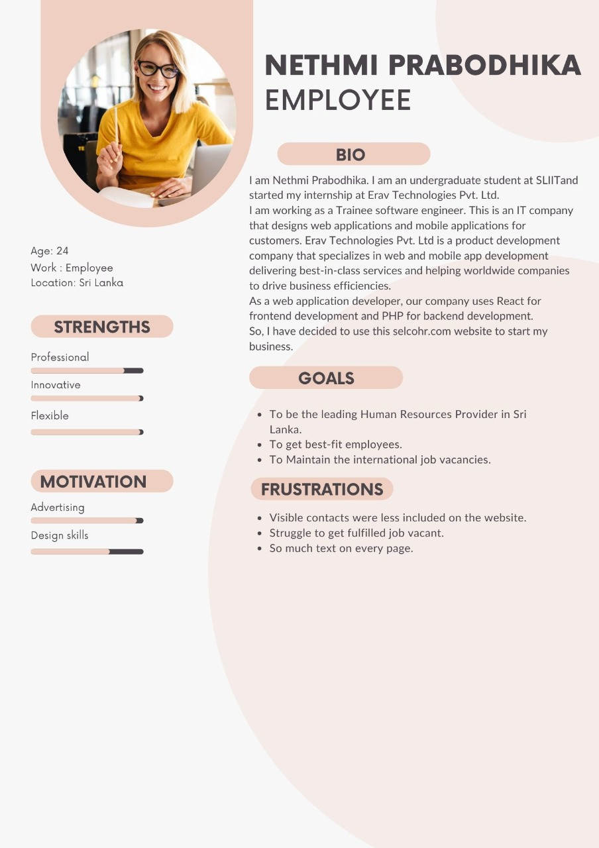

|page 15|

**Job Seeker**

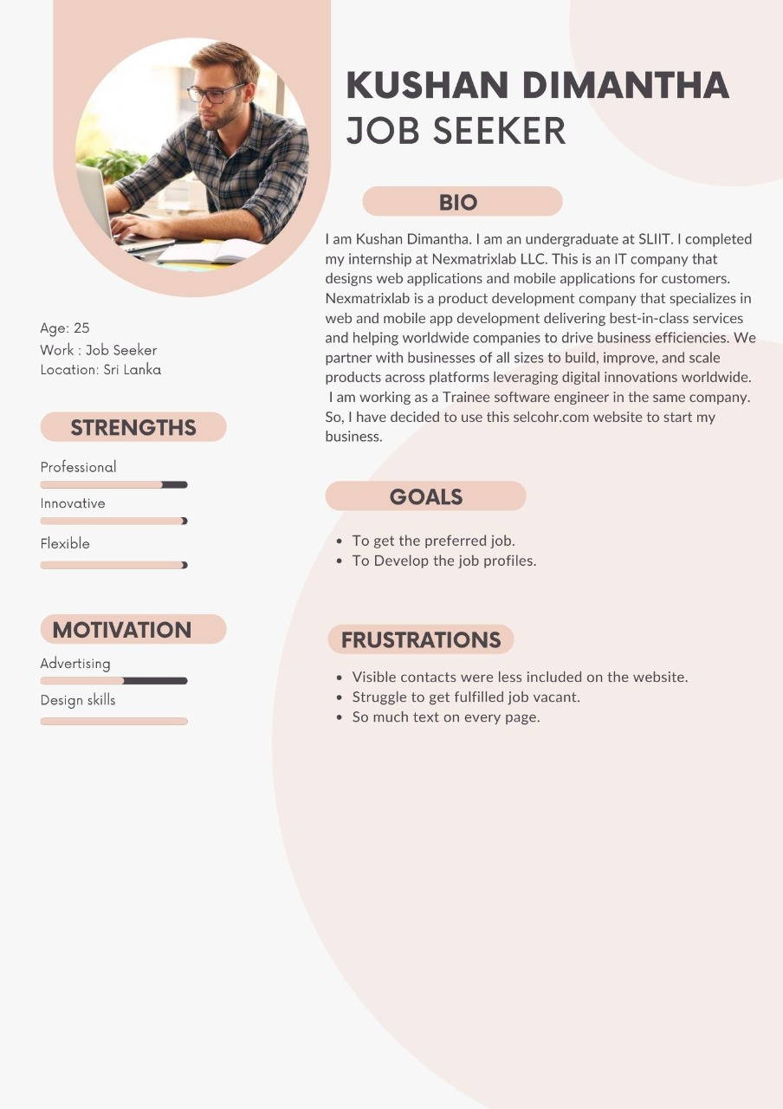

|page 16|

**Recruiters(company Managers)**

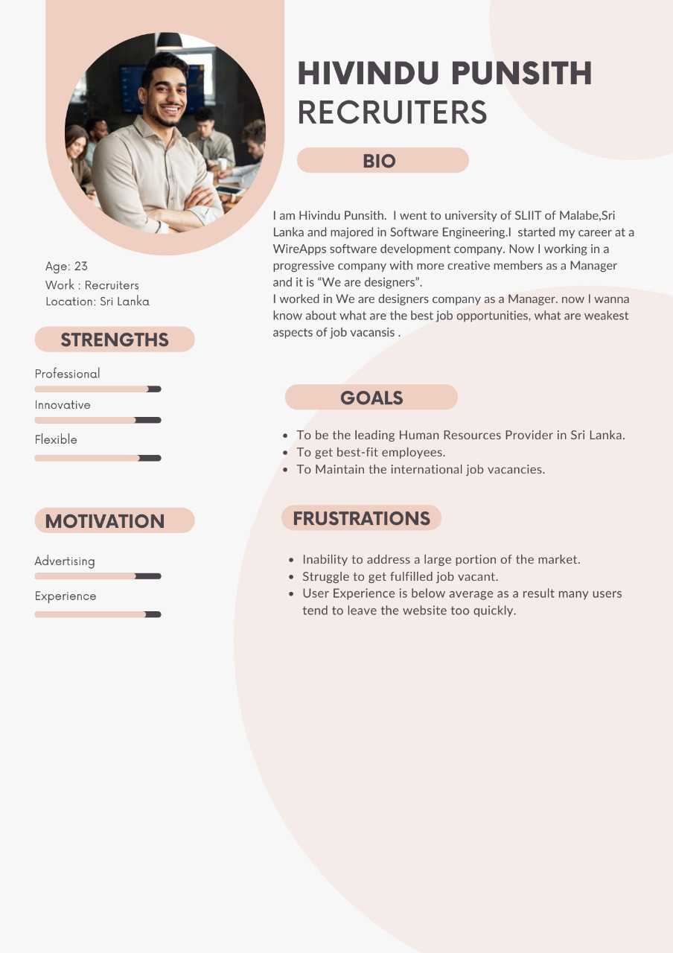

|page 17|

**Scripts for contextual inquiry for 3 users**

**User Category** – **Recruiters** (company Managers)

|  |  |  |
| --- | --- | --- |
| **Background description of the user** | **Questions to be asked from the user** | **Tasks to be given to the user** |
| * I am Hivindu Punsith. I have graduated student at SLIIT. * I had worked at WireApps (Pvt) Ltd as a Manager * WireApps is an IT company that designs software architecture and features, Builds Web,Mobile, Desktop applications for customers. * Company is mainly working with multitenancy architecture and microservice architecture For web application frontend development use PHP Laravel framework. * As web application developer our company use Angular for frontend development,As associate software engineer I newly appointed in We Are Designers International. * I am currently working in here as a Manager. * So, I has decided to use this [**selcohr.com**](https://www.selcohr.com/) website to start my business. | * Have you used any website like this before to start your business? * How did you come to know about this website? * Do you think this website will be useful for your start up? * Is it easier to use this website? | * Can you show us how log in to this web site ? * How do you find job vacancy for an Accountant Assistance? * Can you show me the job vacancy for an IT Manager? * Can you show us how log out from this web site . |

|page 18|

**User Category** – **Job Seeker**

|  |  |  |
| --- | --- | --- |
| **Background description of the user** | **Questions to be asked from the user** | **Tasks to be given to the user** |
| * I am kushan DImantha . I am an undergraduate at SLIIT. * I had completed my internship at Nexmatrixlab LLC. * This is an IT company that designs web applications and mobile applications for customers. * Nexmatrixlab is a product development company that specializes in web and mobile app development delivering best-in-class services and helping worldwide companies to drive business efficiencies. * We partner with businesses of all sizes to build, improve, and scale products across platforms leveraging digital innovations around the world. * Now I am working as a Trainee software engineer in the same company. * So, I has decided to use this **selcohr.com** website to start my business. | * Are you searching job vacancies in any website * What do you think about the login page * Have you found a job thorough this site * What do you think about the interface      * What are the expected things to be changed in this interface * What is your opinion about this site user attraction (font size/color) | * Login to the site using login details * Navigate to job seeker profile * Please navigate the preferences page. |

|page 19|

**User Category** – **Employee.**

|  |  |  |
| --- | --- | --- |
| **Background description of the user** | **Questions to be asked from the user** | **Tasks to be given to the user** |
| * I am Nethmi Prabodhika. I am an undergraduate student at SLIIT. * I started my internship at Erav Technologies Pvt. Ltd. * I am working as a Trainee software engineer. * This is an IT company that designs web applications and mobile applications for customers. * Erav Technologies Pvt. Ltd is a product development company that specializes in web and mobile app development delivering best-in-class services and helping worldwide companies to drive business efficiencies. * As a web application developer, our company uses React for frontend development and PHP for backend development. * So, I has decided to use this **selcohr.com** website to start my business. | * How often do you use this website * Is it easier to find jobs in this page among the other job seeking sites? * Do you think this website will be useful for your job seeking process? * 4. Is it easier to use this website? | * Can you show us how to register to the system and login as an employee? * Please show me how to find jobs that you preferred? * 3.find the job using your employee category? * Can you show us how log out from this web site . |

|page 20|

**Usability issues identified based on contextual inquiry**

|  |  |  |
| --- | --- | --- |
| User | Interface Name | Usability Issue |
| **Employee** | **Home Page** | * Unnecessary Listing Location link . * Header and footer on the website do not match Home Page * Use of inappropriate colors . * Font size is too small (“It’s annoying to the eyes”) * There are more white spaces * User interface is difficult to user eyes. * Added unnecessary features. * Some functions will not be helping and there are not working . * Not eye-catching interface (“user interface of this site should be developed in such a way as to attract the user”) |
| **Job Seeker** | **Profile Page** | * Form should be more improve * Form details are not user friendly * There are nine main buttons in this web page and it has not proper distance between these buttons. * Main title (Personal details) not centered. * Has a huge light color distance between detail and the value. * Example values are not clear and user friendly * All the personal details are in the same place ,they are not separated. * Difficult to find some details * Warning messages and notices are not user friendly * There are more white spaces * Form is too simple * Unnecessary text field available |
| **Recruiters** | **Search Job Page** | * Interface is messy . * The logo used does not have any quality . * This page is not fully used for the interface . * Some Page titles are missing . * Difficult to find some details. * Difficult to read the content in the drop down list. * Texts are difficult to find and read . * large description and it’s font size is too small. * Description Details are not readable clearly because of small font size. |

|page 21|

**Usability issues identified based on contextual inquiry and ratings of the Usability problems as high medium and low**

|  |  |  |
| --- | --- | --- |
| **User** | **Usability Issues** | **Rating** |
| **Recruiters** | * Not user friendly | high |
|  | * Poor navigation | Medium |
|  | * Less attractive | Medium |
|  | * Poor design structure | high |
| **Job seeker** | * Not responsive | Low |
|  | * Font size is too small | high |
|  | * Poor color combination | Medium |
| **Employee** | * No proper instructions to fill the form. | Low |
|  | * Poor alignments | high |
|  | * Poor structure in paragraphs | high |

|page 22|

**Gantt Chart**

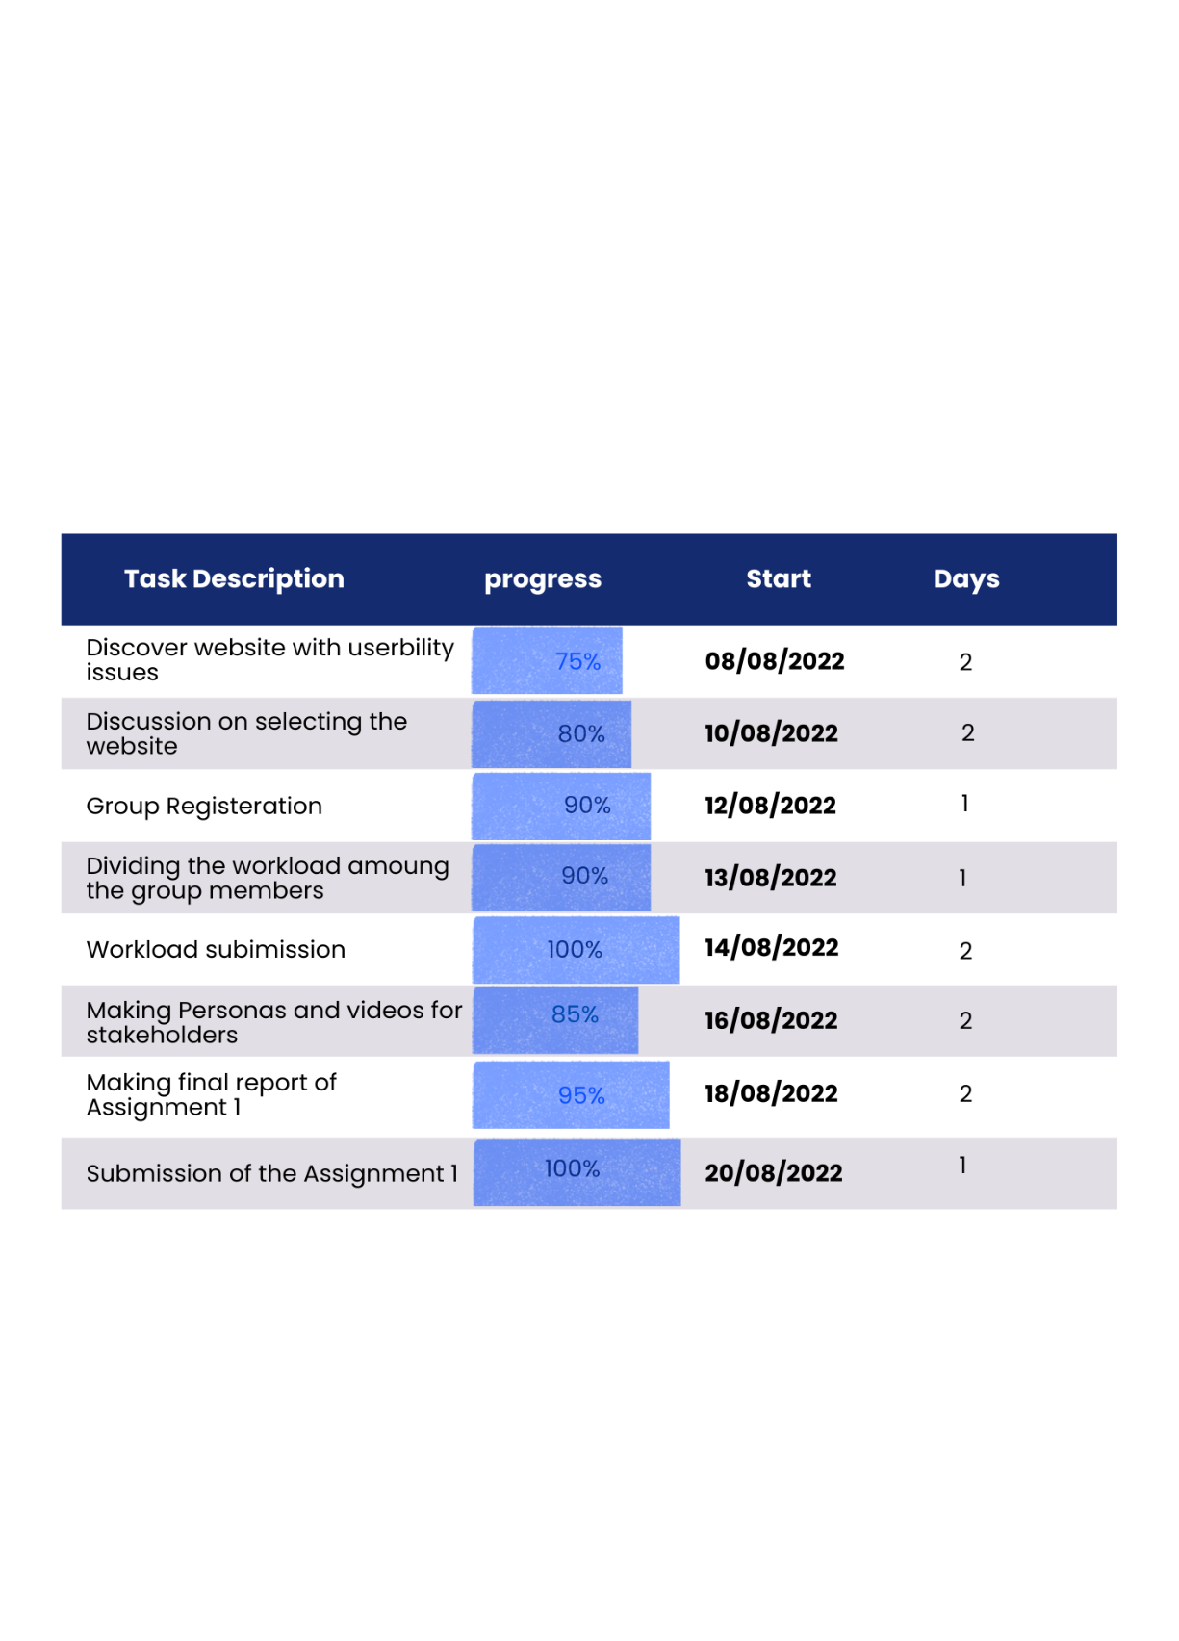

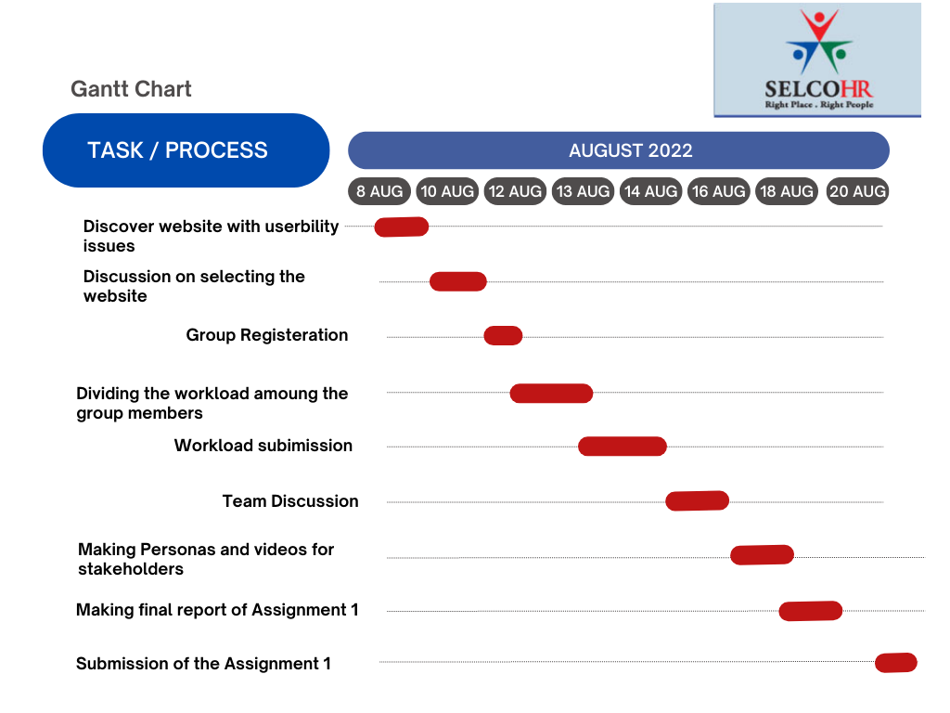

|page 23|

**Video Links:**

**1.Video – Employee**

[**https://drive.google.com/file/d/1Adk28SthykswOwR1MkKAaEI7cMx1YBGT/view?usp=sharing**](https://drive.google.com/file/d/1Adk28SthykswOwR1MkKAaEI7cMx1YBGT/view?usp=sharing)

**2.Video - Job seeker**

[**https://drive.google.com/file/d/1p8HjYwfSh8qpFeMTUaS6Ewd0212wzxo8/view?usp=sharing**](https://drive.google.com/file/d/1p8HjYwfSh8qpFeMTUaS6Ewd0212wzxo8/view?usp=sharing)

**3.Video - Recruiters(company managers)**

[**https://drive.google.com/file/d/1IdQLLYH56_kKrOtkDrMH6QSH1RSHOiWJ/view?usp=sharing**](https://drive.google.com/file/d/1IdQLLYH56_kKrOtkDrMH6QSH1RSHOiWJ/view?usp=sharing)

**References**

* Creating Personas for User Experience Research

https://youtu.be/u44pBnAn7cM

* Example Usability Test with a Paper Prototype

https://youtu.be/9wQkLthhHKA

* Usability Problems

<https://www.invespcro.com/blog/7-methods-to-uncover-problems-on-your-website/>

|page 24|

**Appendix**

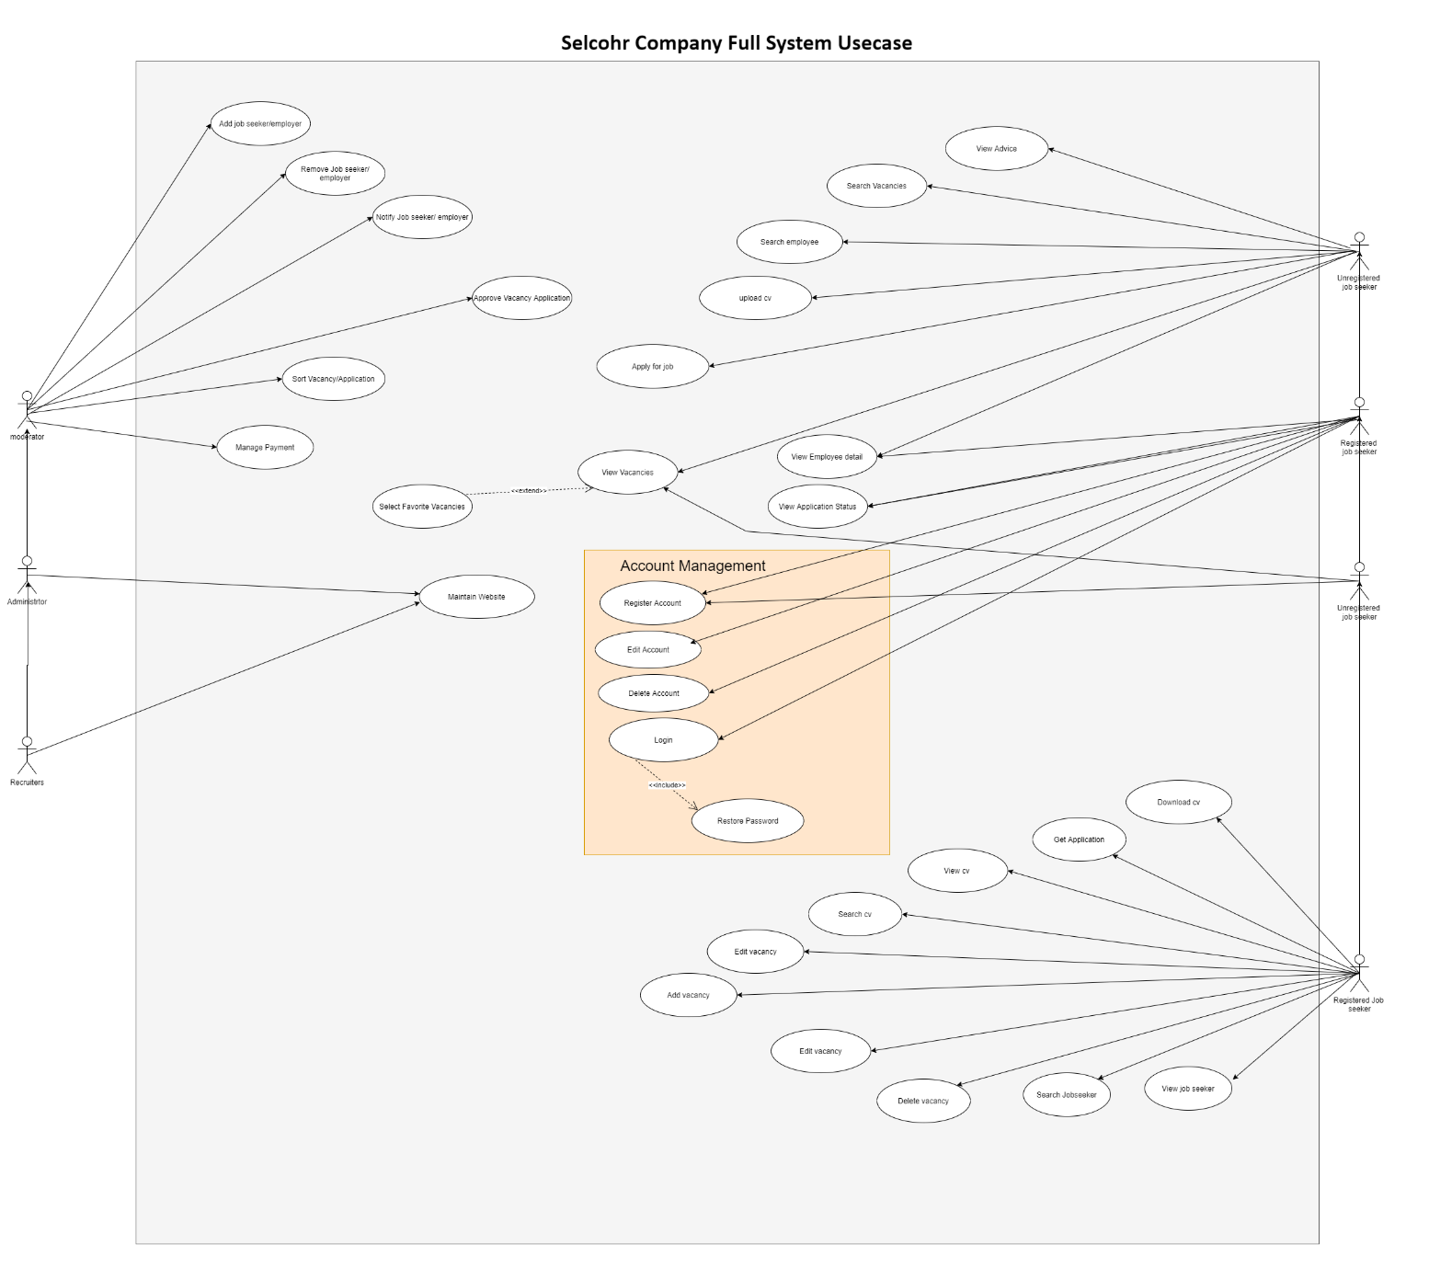

|page 25|